**Project Report**

**Title:**

## BACHELOR OF TECHNOLOGY

Computer science and Engineering

Submitted to

## Ms. Nausheen Fatima

**LOVELY PROFESSIONAL UNIVERSITY PHAGWARA, PUNJAB**

**SUBMITTED BY :-** **Reg***.***No:-** **Roll No:-**

# ACKNOWLEDGEMENT



***SOURCE CODE:-***

***HTML CODE-***

<!DOCTYPE html>

<html>

<head>

 <title></title>

 <link rel="stylesheet" type="text/css" href="anu.css">

 <link href="https://fonts.googleapis.com/css?family=Josefin+Sans&display=swap" rel="stylesheet">

</head>

<body>

<header>

 <div class="mainheader">

  <div class="logo">

   <img src="family-health-services-vector-22323623.jpg">

  </div>

  <nav>

   <a href="#">home</a>

   <a href="Revised_AIS_Rule_Vol_I_Rule_06.pdf" target="_blank">services</a>

   <a href="Qualityofhealthservices.pdf" target="_blank">about</a>

   <a href="#" target="_blank">contact</a>

  </nav>

  <div class="menubtn">

   <button> <a href= “tel:+YOURNUMBERHERE”29-Mar-2019> HelpLine</a></button>

  </div>

 </div>

<!--   DONATION FOR SUPPORT:    PhonePay = vinodbahadur@ybl      GooglePay: vbthapa55@oksbi

 Believe me, all this money will be used to make more quality videos and to make my channel grow. So that I can always provide you awesome free videos :) -->

 <main>

  <section class="left-sec">

   <h2> We Are Here For Your Care</h2>

   <h1>  We The Best Doctors</h1>

   <p>We are here for your care 24/7. Any help just call us.</p>

   <button><a href="f3c290038421011ec27f738e86b2f357.jpg">

     Make an appointment</a>

   </button>

  </section>

  <section class="right-sec">

   <figure>

    <img src="images/mainbg.png">

   </figure>

  </section>

 </main>

</header>

</body>

</html

CSS CODE-

*{

    padding: 0;

    margin: 0;

    box-sizing: border-box;

    transition: 0.5s;

    font-family: "Century Gothic", sans-serif;

 }

 .navlist{

    width: 100%;

    position: fixed;

    padding: 5px 10%;

    background-color: #110e2bbb;

 }

 .navlist ul{

   tab-size: 16;

    display: flex;

    list-style: none;

 }

 .navlist ul li:first-child{

    flex: 1;

    color: #ffffff;

 }

 .navlist ul li h4{

    font-family: serif;

 }

 .navlist ul a{

    display: block;

    margin-left: 100px;

    font-family: "Century Gothic", sans-serif;

    font-size: 0.9rem;

    color: white;

    text-decoration: none;

 }

 .navlist ul a:hover{

    color: #ff8800;

 }

 .main-box{

    width: 100%;

    height: 80vh;

    background-image: linear-gradient(#000000bb, #000000bb), url(../images/background.jpg);

    background-position: center;

    background-size: cover;

    background-repeat: no-repeat;

    color: #ffffff;

    text-align: center;

    padding-top: 30vh;

 }

 .main-box h1{

    word-spacing: 8px;

    margin-bottom: 15px;

    font-family: serif;

    text-align: right;

 }

 .main-box a{

   color:pink;

   text-align: left;

 }

 .main-box p{

    font-family: "Century Gothic", sans-serif;

    font-size: 14px;

    letter-spacing: 1.4px;

    margin-bottom: 40px;

    text-align: right;

 }

 .main-box button{

    text-align: right;

    padding: 10px;

    border: none;

    outline: none;

    background: none;

    border: 1px solid #ff8800;

    color: #ffffff;

 }

 .main-box button:hover{

    background: #ff8800;

    text-align: right;

 }

 .container{

   padding: 100px;

   background-color: black;

   border-radius: 10px;

 }

 .container.ash{

   padding: 1200px;

 }

 .box {

    margin: 10px;

    padding: 10px;

    font-size: 18px;

  }

  .search{

   width: 330px;

   float: left;

   margin-left: 270px;

 }

.anujeet pre{

   white-space: 20px;

}

Result page/Output:-

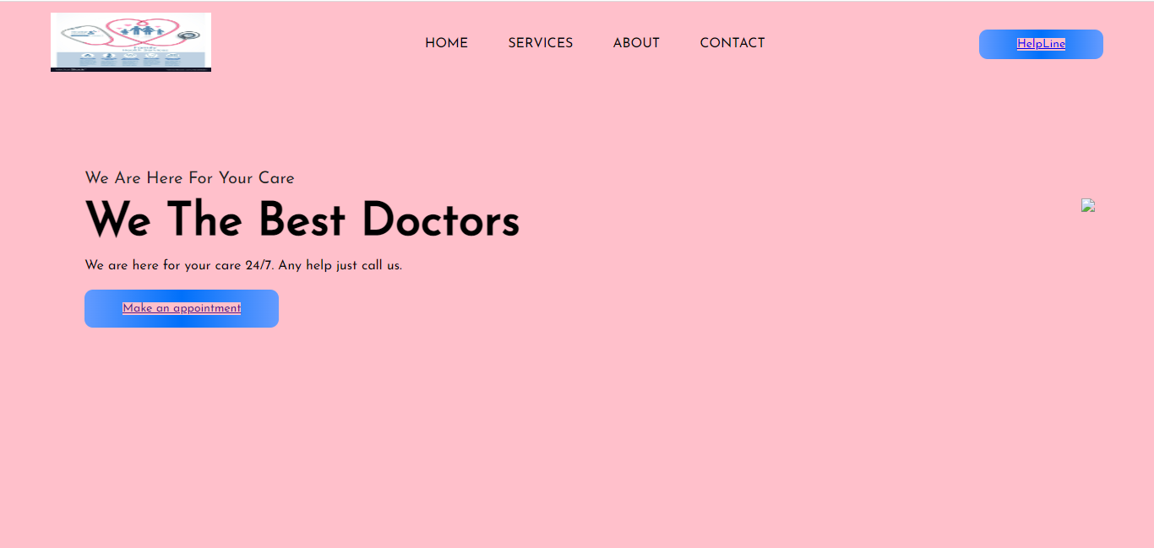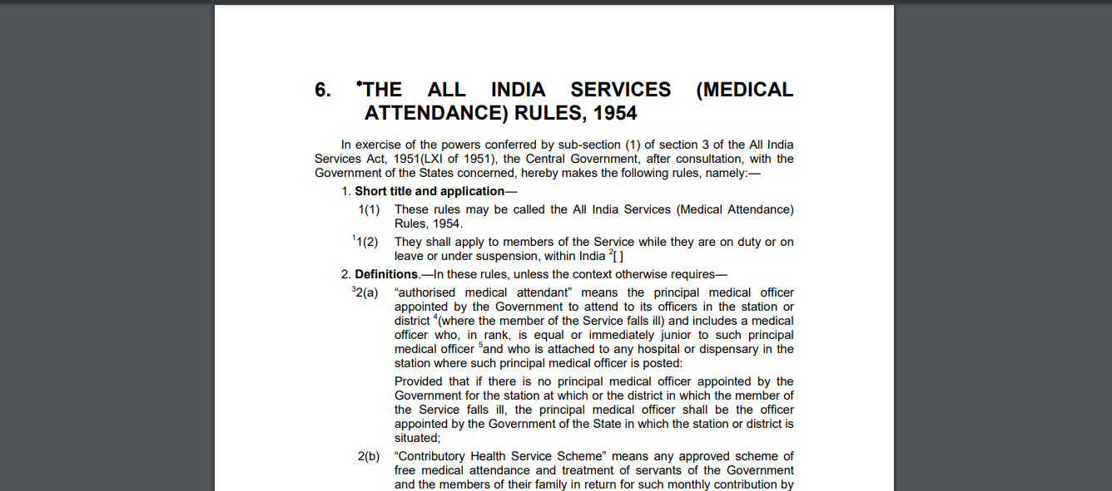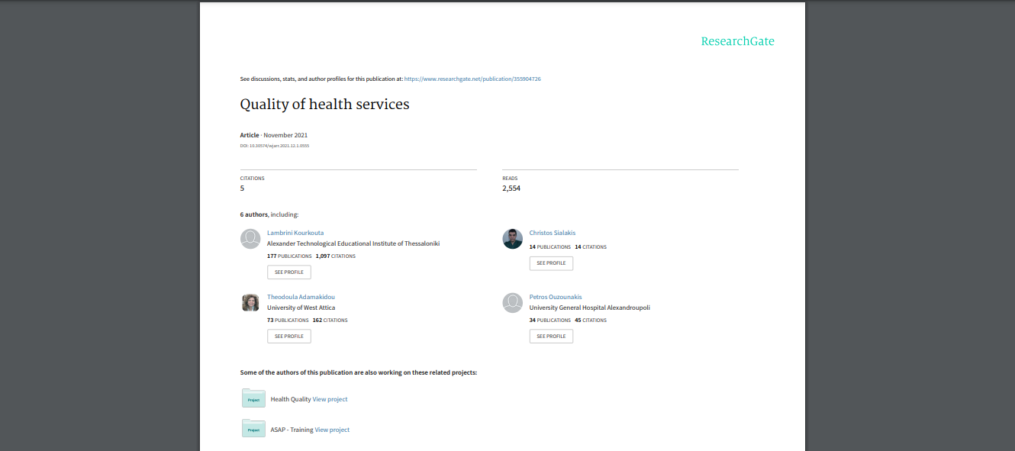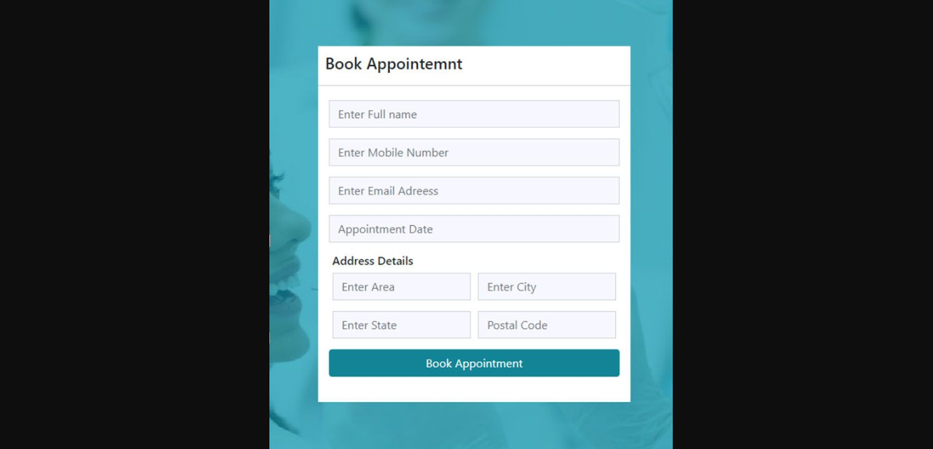

# Conclusion

